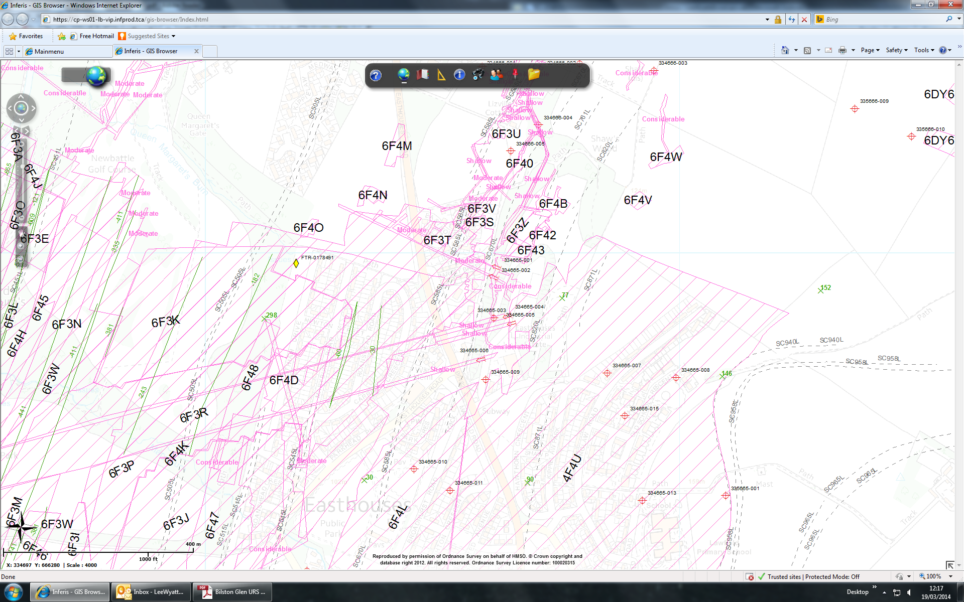

Shallow Workings in North Seam (SC940L)

Easthouses BH

Easthouses Tip

